**MS3 Concept Solution Report**

**Team Seven:** Nathan Anthony, Fanta Cisse, Kismet Crossdale, Kamsi Dozie-Obele, Hayden Fuller, Jameson Giannattasio

**Motor Free Air Compressor**

**IED Section:** 8

**Date:** March 17, 2024

**Introduction**

This design project aims to address the issue of limited access to stable energy in Nigeria. With approximately 47% of the population or around 100.3 million people [1] lacking consistent electricity, there is a pressing need for innovative solutions. This introduction provides an overview of the problem, its scope, potential users and stakeholders, and existing technologies in the solution space.

The problem we aim to solve is the lack of reliable and affordable energy in Nigeria, which has significant consequences for agriculture, communication, healthcare, and overall quality of life. The current state of affairs is inadequate due to frequent power outages, high maintenance costs, and limited affordability of solar panels. Innovative solutions are required to ensure a consistent power supply, minimize maintenance expenses, and make solar energy more accessible.

The scope of the problem is significant, with nearly half of Nigeria's population lacking access to stable energy. This affects individuals, households, agriculture, businesses, and the overall economy. The annual losses due to the energy deficit are estimated at $26.2 billion [1]. Additionally, solar panels' limited lifespan and efficiency contribute to the problem, requiring regular maintenance and replacement.

*Users and Stakeholders*

The primary users of our design solution are low and middle-class families in Nigeria who are most affected by the lack of stable energy. These families rely on electricity for daily activities such as cooking, cleaning, and maintaining a comfortable living environment. The stakeholders involved in this project include the Nigerian government, the Nigerian Energy Support Program, and environmental NGOs. Their involvement is crucial for implementing and supporting the adoption of innovative energy solutions.

*Existing Technologies*

Several existing technologies in the solar panel cleaning space have been benchmarked:

1. Enel Green Power's innovative solution: Enel Green Power [2] is developing new technologies to address the problem of soiling impact caused by sand and dust on solar panels.

2. CleanFIZZ's levitating technology: CleanFIZZ [3] has developed a technology that levitates dust and sand off the surface of solar panels, enabling self-cleaning with zero water, zero manpower, and no mechanical parts.

3. Solar panel cleaning robots [4]: Industry innovation has seen the emergence of solar panel cleaning robots, which offer automated cleaning cycles and reduce the need for human intervention.

*Issues with Existing Technologies*

1. Expensive: The products available are up to hundreds of dollars and none of them are cheap enough for someone of average income to purchase without spending too much.

2. Heavy & nonmobile: Some of the existing products available are heavy and for industry use. They are not for the usual small home.

3. Not for commercial use: In current research endeavors, some solutions with existing technologies seem solely experimental without pricing information or ways to purchase.

*Proposed Solution*

Motor-Free Air Compressor Cleaner Using Infrared Radiation and Pump: Our solution is a motor-free air compressor cleaner that utilizes infrared radiation to heat the gas and build up pressure. This innovative technology offers several advantages, including cost-effectiveness, portability, and versatility in cleaning various objects, including solar panels.

*Advantages of Proposed Solution*

1. Cost-effectiveness: Our solution eliminates the need for a motor, reducing energy consumption and maintenance costs associated with traditional air compressors.

2. Portability: The absence of a motor makes our air compressor cleaner lightweight and portable, allowing for easy transportation and use in various locations.

3. Versatility: In addition to cleaning solar panels, our motor-free air compressor cleaner can be used to clean other objects, such as machinery, equipment, and surfaces, making it a versatile tool for different applications.

The problem of limited access to stable energy in Nigeria necessitates innovative solutions. Our proposed motor-free air compressor cleaner utilizing infrared radiation offers cost-effectiveness, portability, and versatility. By addressing the challenges of cleaning solar panels and other objects, this solution has the potential to contribute to a more sustainable and accessible energy infrastructure in Nigeria. Collaboration with stakeholders and the adoption of such innovative technologies are crucial for achieving long-term solutions to the energy problem in the country.

**Problem Statement**

The present unsatisfactory state in Nigeria is characterized by unstable power and electricity, leading to the inability to use essential services such as the internet, hot running water, and household appliances. Many Nigerians are forced to spend significant amounts of money on power sources like solar panels, which often prove to be inconvenient and ineffective due to the lack of maintenance and cleaning. This situation hampers economic growth, limits access to advanced technologies, and creates daily challenges for Nigerian families, particularly those in the low and middle-income brackets.

The impact of a successful solution would be the unleashing of Nigeria's true economic potential by providing reliable and affordable access to well-functioning electricity. This would enable businesses to operate more efficiently, improve communication and healthcare services, and enhance the overall quality of life for Nigerian households. Everyday tasks would become easier and more convenient, leading to increased productivity and economic growth.

To understand the users and stakeholders in this problem, we focus on Nigerian families and households, particularly those with low and middle-class incomes. These are the individuals most affected by the lack of stable energy and who rely heavily on electricity for their daily activities. The stakeholders involved in addressing this problem include the Nigerian government, energy providers, solar panel manufacturers, environmental organizations, and NGOs working on energy access and sustainability.

The definition of success in this context would be an increase in the percentage of people in Nigeria who have access to well-functioning electricity and power. This can be measured by tracking the number of households or individuals who transition from unreliable or costly power sources to a stable and affordable energy solution.

Identifying innovation opportunities is crucial for finding effective solutions. Some potential innovation opportunities in addressing the lack of reliable and affordable energy in Nigeria include:

1. Decreasing the cost of solar panels: Finding ways to reduce the upfront costs of solar panels would make them more accessible to a larger population, particularly those with limited financial resources.

2. Self-cleaning solar panels: Developing technologies or coatings that enable solar panels to self-clean, reducing the need for regular manual cleaning and maintenance.

3. Shading mitigation: Designing solutions to minimize the impact of shading on solar panels, as shaded panels experience decreased efficiency and produce less energy.

4. Nanostructured surfaces: Exploring nanostructured surface materials that can enhance the efficiency of solar panels by capturing more sunlight and reducing energy loss.

By focusing on these specific innovation opportunities, we can develop targeted solutions that address the challenges faced by Nigerian households in accessing reliable and affordable energy sources.

**User Needs**

Table 1. Summary of User Needs

| **User Needs ID** | **User Need Description** | **Importance (Low, Medium, High)** | **Priority(1-highest, , 5-lowest)** |
| --- | --- | --- | --- |
| UN1 (Creativity) | Our product should be innovative and demonstrate hard work and thorough thinking | Medium | 5 |
| UN2 (Price) | Our product should be low-cost and affordable for all users | High | 2 |
| UN3 (Energy) | Our product should provide more consistent energy to users in areas where the condition of the electrical grid is unstable | High | 1 |
| UN4 (Safety) | Our product should meet basic safety standards and not put any of our users (and non-users, eg. the environment) at risk for danger | High | 3 |
| UN5 (Durability) | Our product should be durable and have a long-lasting shelf life | Medium | 4 |

*Explanation of Chosen User Needs and Rankings*

Our User Needs 1, Creativity, is something we didn’t think about until the latter stages of finalizing our chosen project. At first, we came up with the idea of building a wiper that would automatically wipe the dust and debris off of solar panels. Its simplistic features would make our job easier as a group but are not as innovative and advanced as the world of technology is today. This is what pushed us to create an air compressor powered by solar energy that would be able to clean the panels.

When discussing Price (User Needs 2), it was a mutual understanding that our product would be cheap but not in quality. The identification of our users is mainly low-middle-income families in Nigeria, a developing country, which makes affordability one of our highest priorities.

The problem statement that our team is very vocal about is making energy more available to families in Nigeria (User Needs 3). With that being said, that will always be our highest priority when designing any product. If we can achieve this goal, then we will succeed as a team.

Safety is ranked as a high priority (with a priority level of 3) due to its critical importance in ensuring the well-being of users and non-users, including the environment. The safety of the motor-free air compressor cleaner is paramount to prevent any potential hazards or risks associated with its operation. By prioritizing safety, we aim to instill confidence in users and ensure that the product meets or exceeds safety standards, thereby minimizing the likelihood of accidents or injuries during its use.

Durability is also ranked as a high importance due to its significant impact on the long-term performance and reliability of the air compressor cleaner. A durable product is essential to withstand the rigors of regular use and environmental conditions, ensuring longevity and minimizing the need for frequent repairs or replacements. By prioritizing durability, we aim to provide users with a product that offers sustained performance over its lifespan, thereby maximizing user satisfaction and minimizing lifecycle costs.

Through interviewing users from Nigeria and conducting research with the resources we have, we were able to come up with these 5 user needs (look at Appendix A).

**Design Specifications**

We are designing a means of compressing air without electrical energy for solar applications. The intent of this design is to create an air gun that blows air with enough speed and pressure to remove dust from solar panels, but also to create a design that can be applied to other needs for compressed air where traditional air compressors consume too much power. We propose an air compressor that can pressurize air by two methods. The primary, novel way is by harnessing solar energy to heat air in a rigid container. Alternatively, using a mechanical pump will serve as a way to create additional pressure. Assuming an ideal gas, under constant composition and volume, doubling the temperature, measured in Kelvin, will double the pressure (Equation 1) Using a mechanical pump to increase the pressure serves to lower the temperature needed to attain the desired pressure.

${P_{2}=\frac{T_{2}P_{1}}{T_{1}}}_{}$ (Equation 1)

State 1 is air before compression. State 2 is air after compression

The challenge with this design is maintaining a high temperature, since heating the air is rather slow. The container can be optimized to absorb black-body radiation through various coatings, like antireflective coatings and black paint, however the heat transfer from the walls of the container to the gas is slow [5]. Since this process is inefficient, it is critical to minimize heat loss to the surroundings. Our container should minimize surface area to have the least amount of heat loss due to convection. Another measure against convection heat loss to design our container as a vacuum flask. This is the same technology that Thermos containers use to keep drinks hot or cold for hours. An inner container is separated from the outer container by a vacuum, meaning heat cannot travel between these containers by convection since there is no matter to transport the heat [6]. However, if the outer container is made of a transparent medium, blackbody radiation will still pass into the inner container to heat the air inside.

In order to accelerate the air to a desired speed, a nozzle will be attached to the outlet of the air compressor. A thermometer and pressure gauge will be used to measure the temperature and pressure of the inner chamber to assess the operation of our design and note opportunities for improvement either within or beyond the scope of this class.

Safety features must include a pressure release valve. Since we are designing this device to be portable, so that it can be expanded to applications outside of cleaning solar panels where air compression is a need, we may put handles on the container to make the device easier to move and so the user can hold the device without concern of how hot it is if it’s been left out in the sun for a long time. Durability of the air compressor will be determined by the materials selected. Materials should have a high bulk modulus and glass transition temperature to prevent wear of the device due to pressure and heating.

Table 2. Design Specifications Table

| **Interpreted Need Statement** | **Requirement or Justification** | **Specification (Metric)** | **Specification (Target Value)** | **Other Information** |
| --- | --- | --- | --- | --- |
| Device must have low power consumption | Intent is to use minimum energy to clean solar panels so users get the highest energy output | Will be measured by amount of electrical energy needed to operate the device per unit time | No power consumption. Energy input will be mechanical. | Some electrical energy will be used if we automate the release of pressure |
| Device must be inexpensive to make and maintain | Intent is to design something for a low income population | Cost of materials and labor and manufacturing processes | Under $100 |  |
| Device should be safe | Pressure release valves, ways of measuring temperature and pressure | – | – |  |
| Device should be durable and have a long life-span | Materials do not respond to pressure or heating | Select materials with high bulk modulus and high glass transition temperatures | Chemical glassware should be perfect for this which has a bulk modulus of 300-450MPa and a glass transition exceeding 473K [7] |  |
| Device should have a novel design and application | Device will use solar energy instead of electrical energy to compress air | Materials should have coatings to optimize absorption of black body radiation and heat transfer to the gas inside | Goal is to release air at double atmospheric pressure and with an airspeed |  |

**Benchmarking**

For Milestone 2, our two subteams did separate patent research. Subteam A’s research focused on a wiper cleaning device, while Subteam B’s investigation centered on air compression. Due to this split attention, the research that our team has done overall is extremely diverse.

One patent Subteam A explored was the Pleco Solar Robot [8]. This robot, which was specially built to clean solar panels, utilizes a rotating brush. It can be used without any water or cleaning solution and is incredibly simple to install while cleaning extremely efficiently. Unfortunately, it is extremely expensive and very complex in design. It did, however, help the team realize the importance of our device to not use any water or cleaning solution as it will decrease cost and unnecessary waste.

Another patent that Subteam A examined was the Straight Sweep Windshield Wiper [9]. This product is relatively efficient in its motion ability, has a good length, and is notably simple in design. Despite this, the device does not fully take advantage of its length because it does not make its blade a large proportion of its arm's length. This made the team aware of utilizing the totality of the size of our project. We also grasped the advantageous applicability of rotational motion.

Further investigation led Subteam A to its final patent that the group explored for Milestone 2. The iRobot Roomba [10] was explored due to its debris detection sensor. The Roomba was able to clean efficiently without being impeded by the debris. It detected areas with higher concentrations of debris and fixated on those regions. The robot is extremely durable but regrettably is a higher cost than our target. Nonetheless, the Roomba helped the subteam to take in account the specificity and detection style of any sensor that is used.

Subteam B’s patents related to their device idea, compressed air. The first of these patents was the Bostitch Air Compressor [11]. Unfortunately, it is expensive. However, this Bostich product was highly durable and very lightweight for an air compressor. Also, it was designed in a way that does not require the use of oil. It inspired the group to consider weight in the product’s design.

A supplemental patent that Subteam B reviewed was the Husky Portable Air Compressor [11]. The product contained a large capacity and a noiseless electric design that can be utilized indoors. The size, weight, and price of the Husky are its downfalls, sporting a 4.5 gallon tank while also being costly. Through this patent exploration, the group was interested in designing a product that could be multi-purpose and effective in noise-sensitive environments.

Lastly, Subteam B assessed the RIGID Pancake Air Compressor [11], which was a versatile product with a distinctive “pancake” design that increased its sturdiness but decreased its power output. In relation to the group’s device, the RIGID compressor influenced a more mobile and stable design.

After the two subteams came together and agreed to do the air compressor, we had to do further research into the types of materials needed for our final concept. It was extremely essential that glass [13] and steel [12] be used for the chambers of the air compressor to let in sunlight and absorb and trap heat, respectively. The chambers could also utilize reflective mylar [14] and extremely black paint [15] for heat purposes. Insulation [16] would also be employed since we will not be using a true vacuum on our air compressor prototype. All these materials are further expanded upon in the System Concept Proposal and Subsystems sections.

*Additional considerations concerning benchmarking*

Table 3.1. Benchmarked Item Table.

| **Benchmarked Item** | **Overall Function** | **Pros** | **Cons** |
| --- | --- | --- | --- |
| Pleco Solar Robot | Brushes debris off solar panels with a rotating brush | * Little to no water use * Ease of application * Cleaning efficiency * One-time purchase * Compatibility with solar panels | * Expensive * Not simplistic in design |
| Straight Sweep Windshield Wiper | Brushes debris off windshield with the aid of wiper solution and rotational motion of wiper arm | * Efficient in motion ability * Long wiper arm-length * Simple design * Motor-driven * Low cost * Durable | * Blades are not the entire length of the wiper arm |
| iRobot Roomba | Detects debris and focuses on those areas when cleaning the surface | * Excellent debris detection * Not impeded by debris * Durability * Doesn’t clog * Sensor ability * Piezoelectric sensor * Detects instantaneously rather than build-up | * Expensive |
| Bostitch Air Compressor | Used primarily for trimming. | * Portable * No use of oil for power * Not heavy | * Not low cost |
| Husky Portable Air Compressor | Primarily used for indoor purposes. | * Noiseless * Can be used indoors * Multi-purpose | * Extremely large * Expensive * Fueled by electricity |
| RIGID Pancake Air Compressor | Multi-purpose compressor with a unique pancake design for its tank to support the stability of the structure. | * Durability * Transportable * Extremely sturdy | * Price (not low cost) * Powered by electricity |

Table 3.2. Evaluated Existing Technologies Table.

| **Existing Technology** | **Overall Function** | **Pros** | **Cons** | **Innovation Opportunities in Relation to Our Concept** |
| --- | --- | --- | --- | --- |
| Enel Green Power [2] | Robot that cleans debris off solar panels | * No water use * Automated | * High Price | * No cleaning solution or water required |
| CleanFIZZ [3] | Rises debris into the air off the solar panel | * No water use * Automated | * Very expensive * Difficult to install | * Easy and relatively quick install |
| Solar panel cleaning robots [4] | Clean using self-operating schedules | * Automated | * Costly | * Not operated solely through mechanical power |

To make sure the product was feasible, a couple members of the group contributed calculations. Some calculations have already been explained and addressed in the Design Specifications section. Figures 1a-1c below represent other calculations done to identify the possible pressure and temperature that may be required, using Bernoulli’s equation and Ideal Gas Law.

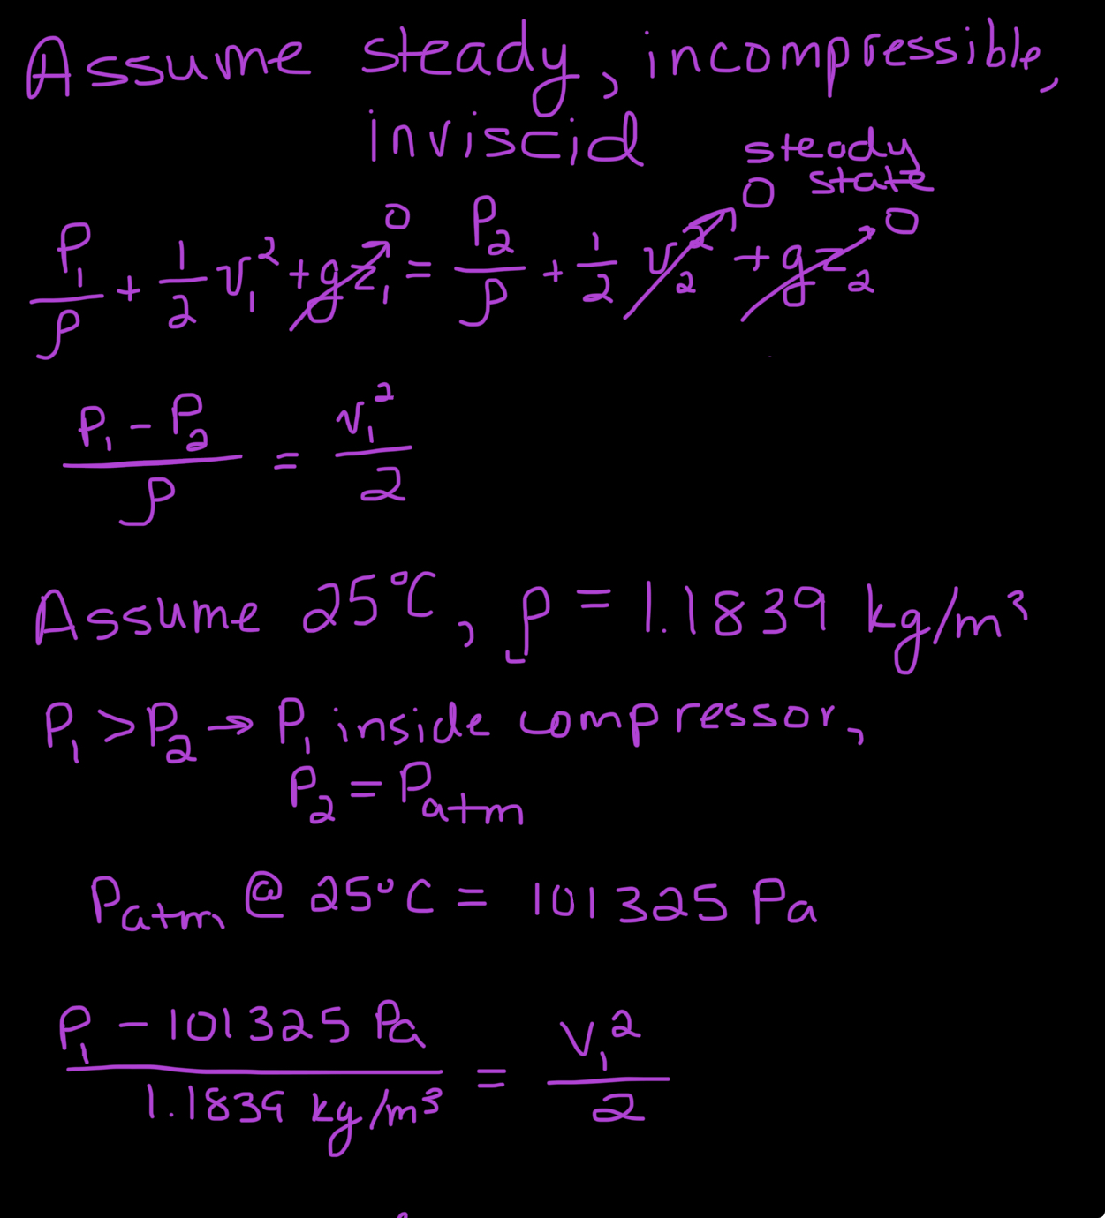

Figure 1a. Pressure Calculations (Bernoulli's Equation).

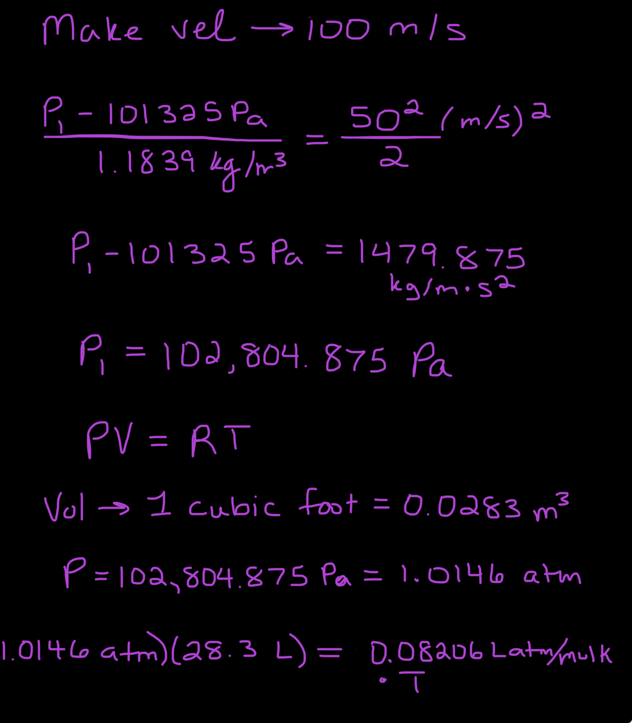

Figure 1b. Pressure and Temperature Calculations (Bernoulli’s Equation and Ideal Gas Law).

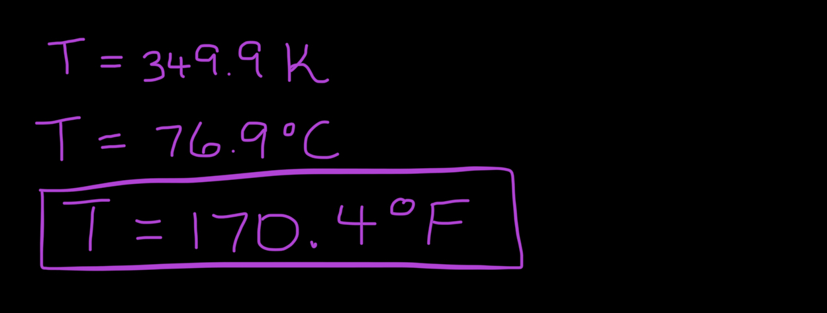

Figure 1c. Temperature Calculations (Ideal Gas Law).

All references are listed in the citations section on the last page of this report, using IEEE format.

**Design Alternatives**

In the process of developing an idea for an air pressurized cleaner for solar panels, several creative and viable solutions were discussed from the concept generation process in milestone two.

*Mason Jar and Pressure Sensor*

One of our first designs involved a mason jar inside of another mason jar, with the jar on the inside being slightly smaller than the one on the outside. The mason jars would be air tight with a vacuum pulled in the space between the jars to trap the heat within the inside mason jar. A lever would be connected to the inside mason jar that when opened, would lead to a funnel and shoot air through the point.When left out to absorb solar radiation, the mason jars would heat up and therefore build up pressure. A pressure sensor would be connected to the inside of the inner mason jar that would relay to the lever when the pressure is high enough to open and release the air onto the solar panel. A sketch of the proposed alternative design can be seen in Figure 2. A low fidelity prototype of the model was also created during the concept generation process as shown in Figure 3.

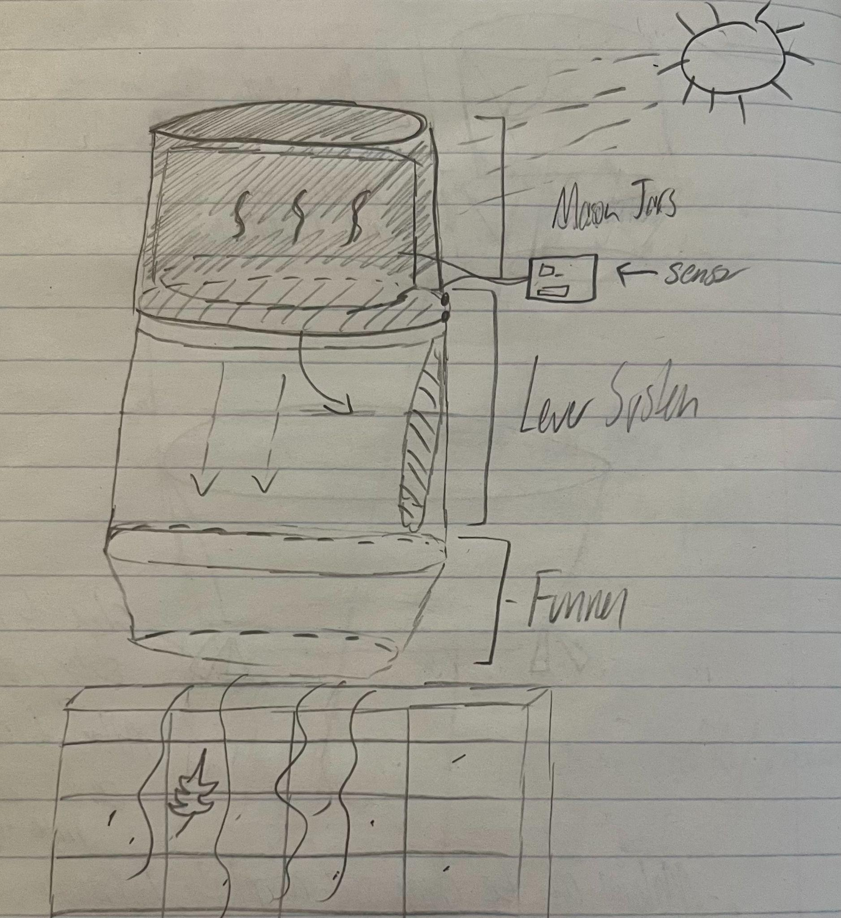

Figure 2. Sketch of mason jar and pressure sensor air compressor using solar radiation

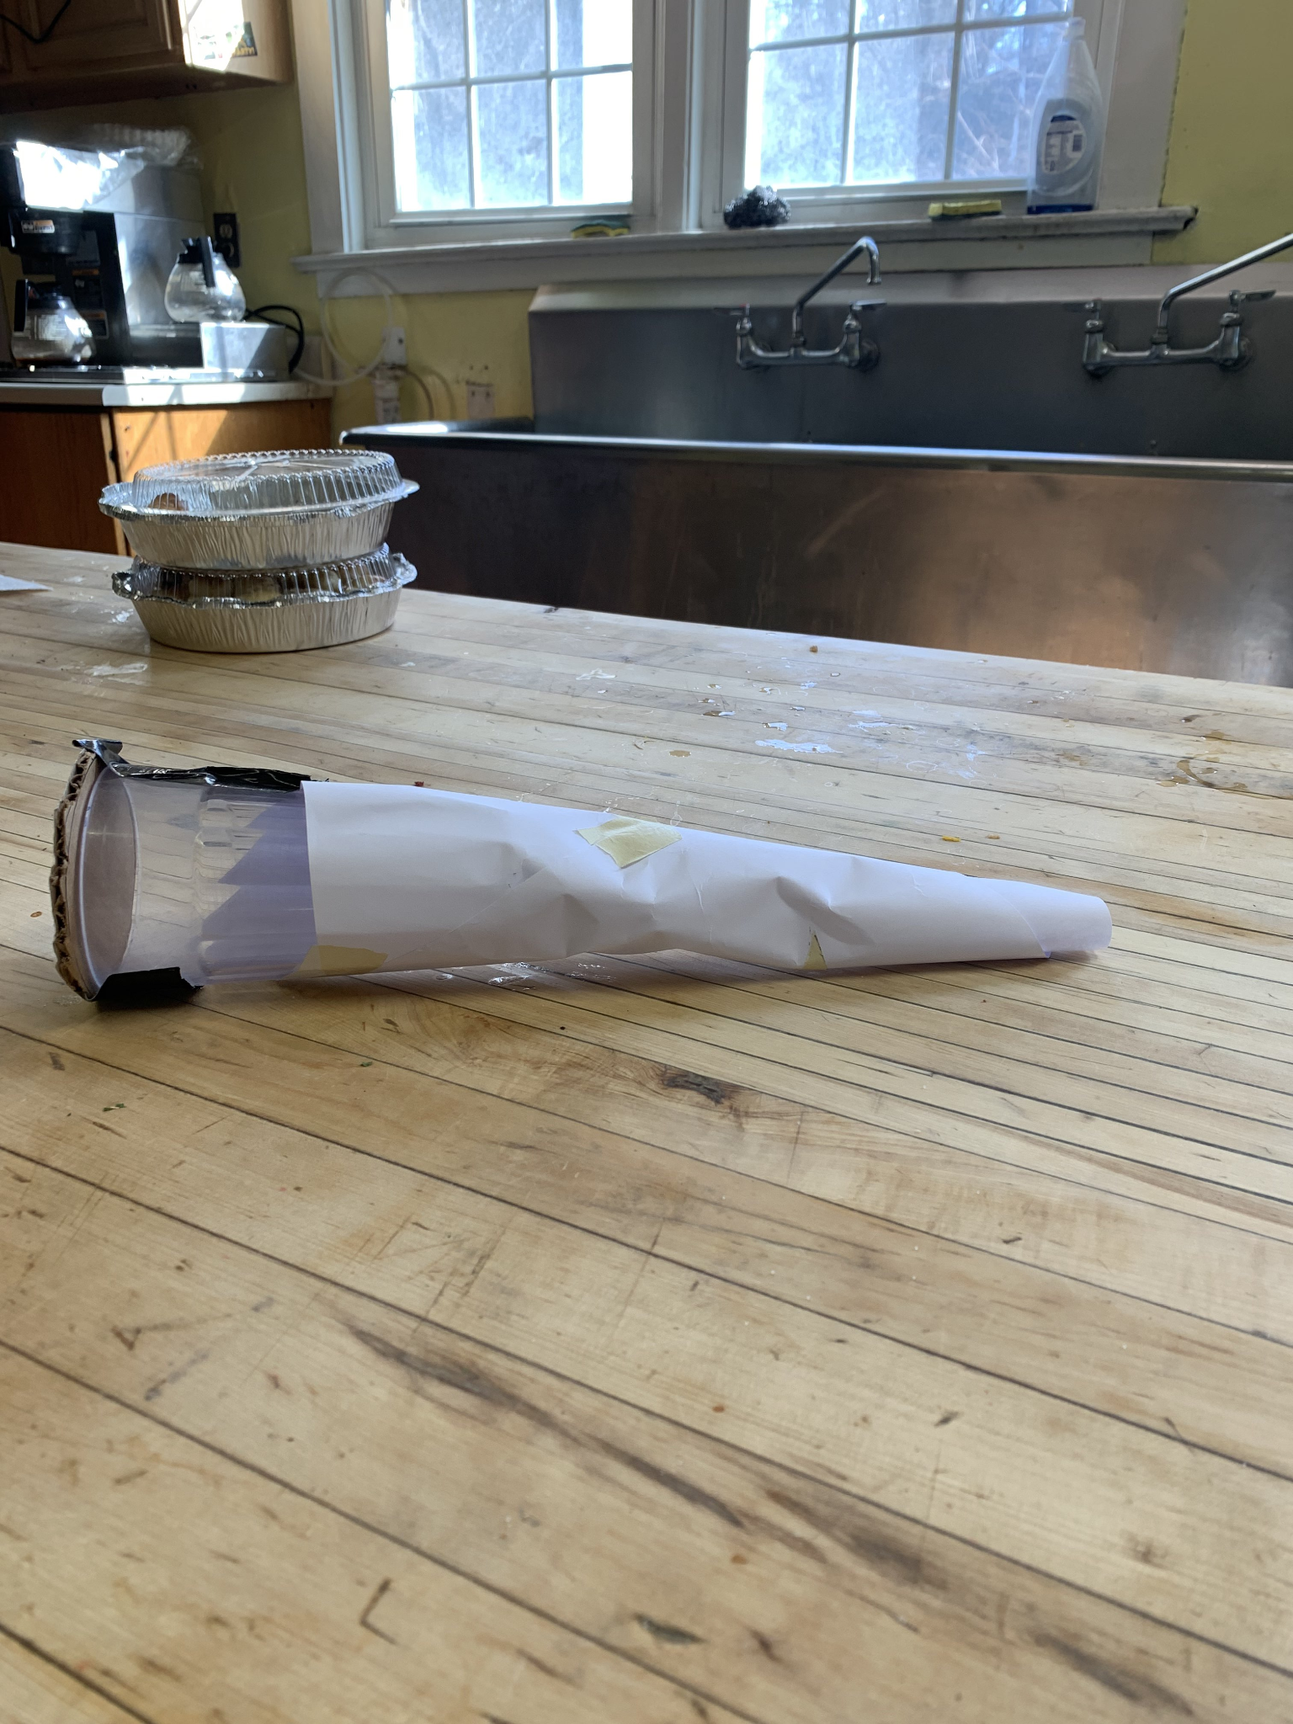

Figure 3. Low-fidelity prototype showing glass container connected to a funnel

This alternate idea would be able to achieve some of our most important metrics discussed in the concept generation process. Price would be low due to simplistic choices of materials that can be easily accessible while the size and weight of the design would be minimal due to smaller lightweight materials. Unlike the benchmarked solution “Bostitch Air Compressor”, this solution would provide compressed air automatically through the use of the pressure sensor and lever system. Where this design falls short is the amount of pressure that is built within the mason jars. Without an initial build up of pressure within the container, the increase in temperature may not prove to be enough pressure increase to blow the debris off of an entire solar panel. Additionally the surface area of the mason jars do not allow for a maximum absorption of solar radiation due to their cylindrical shape, meaning the temperature will not increase as much as it would be needed to supply enough air pressure. Similarly to the “Bostitch Air Compressor”, this alternative design would use electricity for some of its components but at a much smaller scale than the benchmarked solution. Electricity is used to create compressed air in the Bostitch whereas it is only used to sense pressure and operate a lever in our design.

While the amount of electricity that would be consumed is small, we strayed away from this design to allow for a more energy efficient solution to further increase inclusion. The mason jar concept was created keeping in mind the society of the targeted users in Nigeria by utilizing simple materials that can be produced cheaply in a wide range of regions.

*Schlenk Flask*

Schlenk flasks are a type of flask that allows for gasses to evacuate or fill the container with ease. Two stems are connected to the flask, with one being a shorter and more wide opening while the other is longer but more narrow. A stopper will be plugged into the shorter stem to trap the air molecules within the flask while the longer stem will act as our pipe to output air pressure. Pressure can be increased in the flask by closing the valve connected to the longer stem and allowing the flask to absorb solar radiation, increasing the temperature within the container. The longer stem will be connected to an air hose and air blow gun, allowing for users to use the pressure buildup to blow air in any direction manually. A sketch of the Schlenk flask alternative design can be seen in Figure 4.

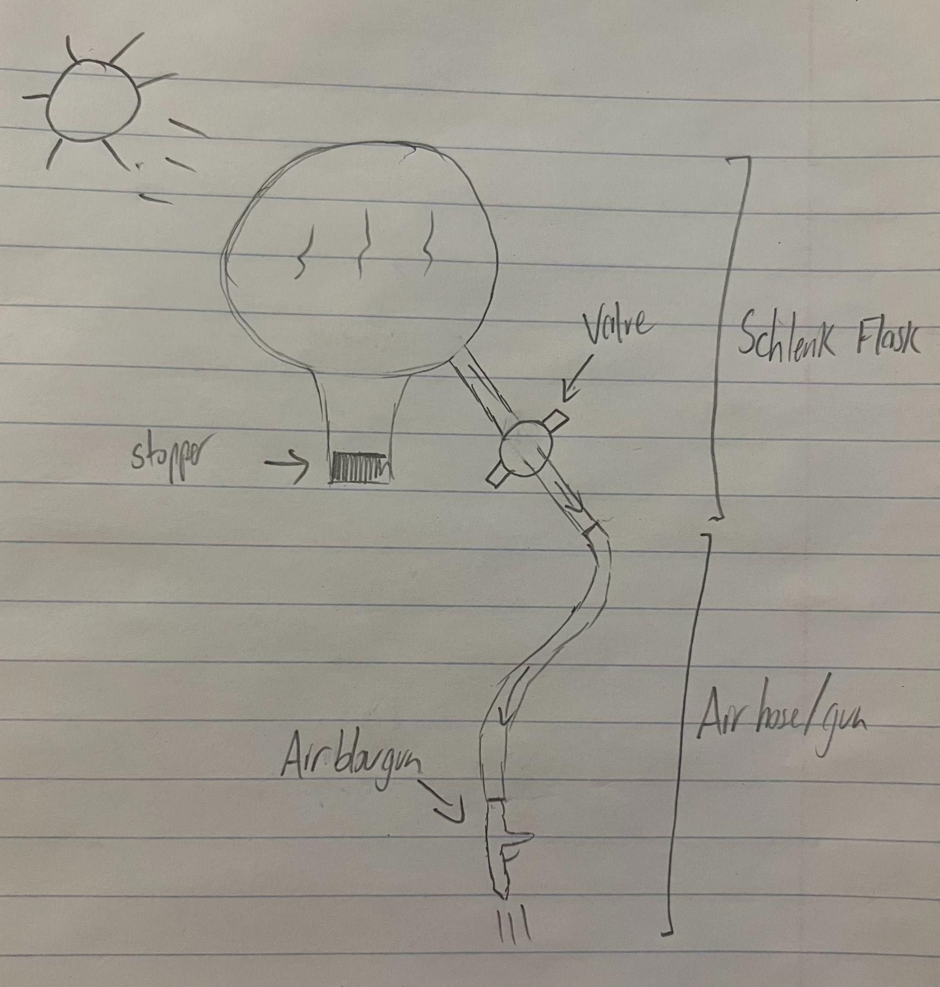

Figure 4. Sketch of motor and electricity free air compressor using Schlenk flask

During brainstorming sessions for the concept generation process, the idea of a design small enough to hold came up, leading to the creation of this alternative design. By screening this idea with our specifications, it was found that this product would be simplistic for users to understand containing a minimal amount of components. Size would also be minimized with this design, allowing for ease of transportation and accessibility for all users. Price would not be too high, with most of the expenses coming from a Schlenk flask that is large and sturdy to contain a large amount of air pressure. A comparable benchmarked solution would be the “Husky Portable Air Compressor” due to its transportability. The Schlenk flask design had the advantage when it comes to what is needed to power the designs because the flask can be pressurized without the use of electricity unlike the Husky air compressor. While the alternate design is lightweight, it may not be easy to transport when heated up because the flask may be too hot of a temperature for humans to handle freely. The amount of solar radiation being absorbed by the flask is also not optimal because of its spherical shape, which minimizes the surface area that would be exposed to the sun when trying to increase the temperature of the flask. Total pressure within the flask will then be limited because it will not be heating up as effectively as possible.

As mentioned previously, this device contains a small amount of total components that are not complicated to reproduce, increasing the accessibility of this design to families in Nigeria. With the only large expense coming from the construction of a durable Schlenk flask, the price of the total design will remain relatively low and allow for a more affordable design than an air compressor utilizing gas or electricity. Removing the need for electrical power to build up pressure within a system strikes one of the largest societal considerations for families without access to a consistent source of energy.

*Isothermal Compression*

In the previous design alternatives, isochoric heating was used to build pressure within a container to be released on a surface by absorbing solar radiation. Isothermal compression was next in line for the method of choice to build air pressure. What this process does is compress a container, effectively decreasing the total volume the air molecules can occupy and thus increasing the pressure in that area. For the design aspect, a rigid container will have a lever connected to the bottom that opens when the solar panel is not operating efficiently, implying that the surface is not clean, to let the built up air pressure out onto the panel. Efficiency of the solar panel will be measured using a sensor that would connect to the solar panel and the lever. Connected to the top of the container will be a motor that pushes a piston down the container until there is enough pressure built up in the remaining space between the piston and lever. Figure 5 depicts a sketch of the general shape and structure that the isothermal compression design would take.

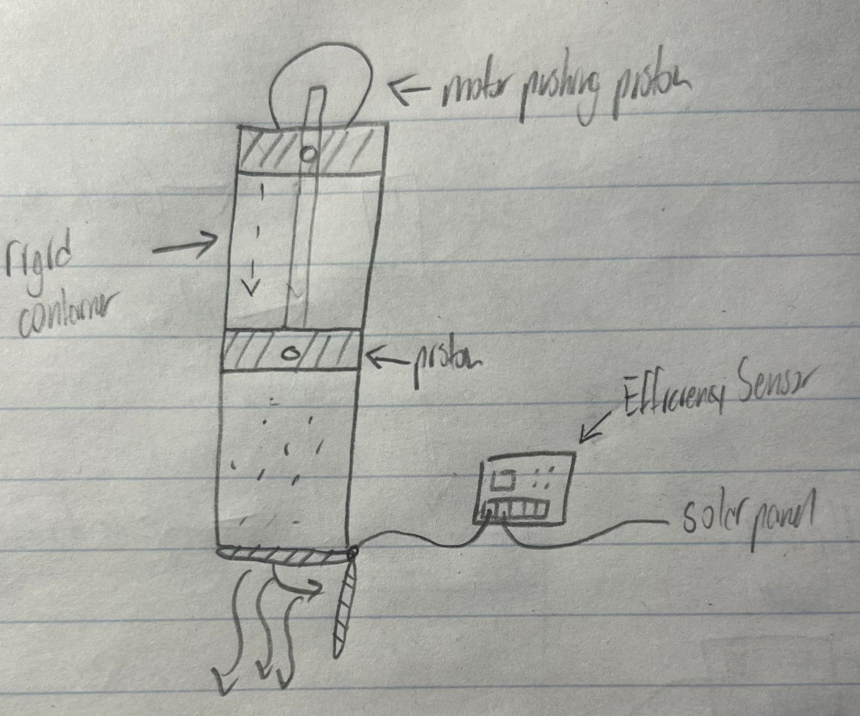

Figure 5. Isothermal compression using motor and piston

Pressure buildup within this design would prove to be significant, allowing for users to have a reliable source of air pressure to clean solar panels with. Cleaner solar panels will mean that energy is maximized from the sun without much energy loss due to debris. The price of this system may be greater than the other system alternatives however due to the implementation of a higher powered motor. When compared to the benchmarked solutions of electrically powered air compressors, the isothermal compression design would be cheaper to create and less expensive to run in the electricity it requires. While this alternate design may not use as much power as the benchmarked solutions, it does still need some form of electricity which is not optimal for our specification of a low energy use product. There may also be some problems with directing the air flow into a specified direction without manually changing where the lever is facing. Since solar radiation is not necessary for this concept, the compressor may be utilized in other areas besides solar panels and could prove efficient in providing pressure in areas not in direct sunlight. The use of a small number of materials as well as remaining relatively cheap when compared to higher powered electrical air compressors shows considerations when thinking about the targeted users of this product.

**Concept-Screening/Selection**

Table 4. Decision Matrix

| **Specification** | **Weight** | **Two Mason Jars** | **Steel Box with glass top** | **Pipe and glass tube** |
| --- | --- | --- | --- | --- |
| **Vacuum insulating ability** | **10** | **6** | **6** | **6** |
| **Surface area** | **10** | **6** | **8** | **3** |
| **SA to volume ratio** | **10** | **3** | **8** | **3** |
| **Cost (cheap)** | **10** | **8** | **5** | **3** |

**Total Score: 23 27 15**

**System Concept Proposal**

Our group’s final concept solution is a solar powered air pressurizer. The design includes a way to manually pump air into the chamber, a solar chamber to multiply the pressure, a few instruments to monitor the temperature and pressure in the chamber, a hose to allow the air to be used for various purposes, and handles for portability.

The solar chamber will consist of an inner heat/pressure chamber built out of steel, enclosed by another slightly larger chamber with a glass top, such that a vacuum can be pulled in the space between the two chambers to allow light to enter and heat the inner chamber while still insulating it so the heat can’t escape. The inner chamber will be interfaced with through a pipe leading to the exterior. This pipe will house a pressure and temperature gauge, a safety valve, a valve to interface with the air hose, and an interface for a bike pump.

The functionality of each subsystem will be tested in MS4, and the entire system will be tested and evaluated in MS5. The chamber will be initially pressurized with the manual pump, pressure and temperature will be noted, and the chamber will be left in the sun or under a heat lamp. Once the temperature of the chamber stops rising, temperature and pressure will be noted, and the hose will be used to clean a dusty surface. We will note how much pressure/airflow was available, how long it was available for before running out, and what surface area was able to be cleaned in that time.

Refined sketches, schematics, and diagrams, as well as the block diagram, can be found in the appendix B figure B2.

**Subsystems**

The final concept solution will contain a total of three subsystems, each performing important and necessary functions to accomplish the goal of creating a motor-free air compressor. The three subsystems that have been identified by the group include the solar chamber, the connecting pipe with sensors placed into it, and both the nozzle and pump. Each subsystem will be covered in more detail in the following subsections.

*Solar Chamber*

The solar chamber will be the largest subsystem in both size and cost. This chamber will include two similarly shaped boxes labeled as the outer chamber and inner chamber. The outer chamber will measure 12 inches (length) x 12 inches (width) x 2 inches (height) composed of two different materials. Steel will be used for the bottom face as well as the walls while borosilicate glass will be used for the top face. Mylar will be attached to the outside walls of the outer chamber to allow for better insulation of heat within the chambers. Dimensions of the inner chamber are close to the outer chamber, measuring 11.5 inches (length) x 11.5 inches (width) x 1.5 inches (height) composed of steel for every face. Black paint will be used to cover the faces of the inner chamber to maximize the amount of solar radiation absorbed. Supports will be placed inside of the outer chamber to hold the inner chamber and create a space between the walls of both chambers. Ideally a vacuum would be created between the two chambers, but insulation will be placed in the space instead in the current state of our design. Insulation will trap the heat in the boxes, allowing for temperatures to increase and maintain a higher temperature for longer. A hole will be created in the bottoms of both chambers to allow a pipe to connect to our inner chamber. The holes will overlap each other so that the pipe can pass through the outer chamber to connect to the inner chamber.

The solar chamber’s main functionality is to store and increase air pressure through solar radiation and mechanical pressure buildup. Pressure from the mechanical pump will be input into the inner chamber, initially increasing the amount of air pressure in the system. Solar radiation will then be input into the inner chamber by absorbing sunlight through the glass of the outer chamber. Resulting from this will be an increase of air pressure within the inner chamber due the combination of increases of temperature and increases of pressure. The amount of pressure that can build up within this system depends on the amount that we initially supply through the pump subsystem, which connects to the pipe subsystem. To ensure that the design is controlled, the materials used must meet the specifications of withstanding high temperatures as well as withstanding high pressure buildups without breaking or warping. In order to be certain that our materials can handle high pressure and temperature situations, tests of heating up the containers to temperatures we expect will need to take place as well as building up significant amounts of pressure into the chambers. While conducting these tests, measurements can be taken to track how well heat is insulated as well as if pressure is built when the temperature increases take place.

With prior experience in the machine shop, the team members Nate and Hayden will be some of the best choices because of the materials and machines that will need to be used in the creation of this subsystem. Four square feet of steel and one square foot of borosilicate glass will be needed for this subsystem. McMaster-Carr prices a square foot of steel at $20.47 [12] and a square foot of borosilicate glass at $61.25 [13]. This results in a price of $143.13 for the steel and glass components of this subsystem. Reflective mylar coating is priced at $25 [14] while black paint can be found for $7 [15]. Both of these coatings for the inner and outer chamber can be found on Amazon. Insulating material to be placed between the walls of the inner and outer chamber can be found at Home Depot for $14 [16]. This subsystem will cost roughly $189.13 to produce using these metrics, or $31.52 per member of the group.

*Pipe and Sensors*

The pipe and sensor subsystem is crucial for connecting every subsystem together as well as assuring safety and functionality of the device. A 9 inch (length) steel pipe with a diameter of 1 inch will be capped off on one end with the other connecting to the inner chamber, which is a part of the solar chamber subsystem. Connected directly into the pipe will be a temperature sensor, a pressure sensor, and a safety valve. In addition to the sensors and valve, there will be two more connections from the nozzle and pump subsystem.

Maintaining safety is enhanced through the use of a pressure sensor and safety valve in this subsystem. A safety valve will ensure that the pressure within the pipe and connecting inner chamber does not exceed a certain threshold of pressure while the pressure sensor allows for users to understand how much pressure the container holds at the moment. The temperature sensor acts as a sign to tell the user that the solar radiation is proving to be effective and effectively heating up the container. Due to the pipe connecting to each subsystem, it contains several inputs and outputs from both components. The solar radiation from the solar chamber causes the pipe to increase in temperature as well, resulting in an increase in pressure buildup. Pressure is also input from the pump subsystem that connects directly into the pipe in order to build up pressure initially. These inputs allow for the pipe and inner chamber of the solar chamber to build up pressure and output compressed air to a nozzle that connects to the pipe. This pipe must be large enough to house all of the components that connect to it, but small enough to allow adequate pressure buildup within the entire system. Additionally, the pipe must be able to withstand high pressure and temperature situations like the solar chamber. A design can be created using CAD to confirm that all of our components will fit onto the small work area available before implementing the real model. Once a real model is constructed, similar heat and pressure tests should be conducted on the pipe to guarantee a sound material that will not warp or break given real world test cases.

A 12 inch pipe can be purchased using McMaster-Carr for around $6 [17], which can be shortened to our needed 9 inch pipe. The pressure and temperature sensors can both be found on Amazon for prices of $6 [18] and $13 [19] with connecting valves costing around $8 [20]. The safety valve can also be purchased on Amazon for $12 [21], bringing the total cost of this subsystem to $45, or $7.50 per group member.

*Nozzle and Pump*

The nozzle and pump subsystem is the area in which the users will perform actions to allow for the product to work. A mechanical pump powered by the users that can supply up to 100 PSI will need to be utilized to create enough pressure in the chamber before solar radiation begins. A valve will need to be implemented to allow for the pump to pressurize the pipe that it connects to without leakage. In order to release and direct the air pressure that is built within the chamber, a hose connected to an air blow gun will be attached to the pipe as well. The hose and air blow gun will have a maximum operating PSI of 185. Another valve will be utilized for the connection between the hose and the pipe to alter whether air is able to flow to the air blow gun or not. Users will be able to control where the air is being directed by simply aiming the air blow gun in the direction that they want to send air to and pressing the lever on the blow gun.

Blowing pressurized air out of the blow gun as well as providing sufficient initial pressure using the mechanical pump are the main functions that this subsystem needs to address. Mechanical energy from the users is needed as an input for the pump to create and build pressure into the chamber. This pressure buildup is then increased due to solar radiation and is then used as an input for the nozzle. Pressurized air is fed into the hose and released onto the desired surface when the user presses the lever on the blow gun, resulting in a clean surface using air. Build up of pressure to be released comes directly from the pump as well as the solar radiation from the solar chamber. Both the nozzle and pump components are connected to the pipe subsystem through valves that must hold pressure within the pipe and inner chamber. For both the nozzle and the pump, maximum PSI values must align with each other as well as the other subsystems. The nozzle and air hose maximum PSI should be high enough to handle the pressure that the chamber and pipe can hold. Tests of high PSI inputs into the nozzle and air hose can be conducted to explore how the subsystem performs based on different PSI values. Air pressure input from the mechanical pump should also be explored by testing maximum values of pressure that can be input by the pump into the pipe and chamber subsystems without causing damage to the mechanical pump.

For our design, we will use a bike pump that is able to pump up to 160 PSI and a valve that allows a connection from the pump to the pipe. Both of these products can be bought on Amazon for the prices of $10 [22] and $6 [23]. The air blow gun nozzle and the air hose can both be found on Amazon with high maximum pressure values for the prices of $13 [24] and $22 [25]. A coupler to connect the air hose to the pipe without leakage in air can be purchased for $5 [26] from Harbor Freight. The total cost of the nozzle and pump subsystem will then be $56, or $9.33 per group member.

**Planning**

Our team utilizes a virtual calendar (Fig. 6) to remember important deadlines and team meetings. We have all our important dates in one place. Our team prioritizes tasks based upon the existing events within the calendar. For instance, if we have a milestone approaching, the group organizes meetings accordingly. Within these meetings, the team delegates tasks to certain individuals. Sometimes we meet as a group to collaborate on the entire assignment. Our methods depend on the makeup of the project and the strengths of our group. Even when we entrust an individual with a task, that person is always welcome to ask input from other individuals or the group as a whole.



Figure 6. Virtual Calendar

We have a text message group in which our secretary, Kismet, sends reminders about meetings and summaries of classes that any of our members miss. Our secretary is responsible for writing our meeting agendas, organizing our virtual calendar, and creating and maintaining our collective Google Drive. Our meeting agenda consists of topics and tasks that need to be completed and/or discussed. Usually, the topic of the meeting will be made clear in the event posting of our virtual calendar. However, in some meetings, several issues need to be addressed, in which the meeting agenda is most useful. Our Google Drive is a collective of meeting agendas, class material, and document outlines for future assignments if we have already been granted the rubrics and guidelines for those assignments.

Additionally, our team continues to use our Gantt Chart (Fig. 7) to distribute roles for tasks we need to complete. As presented in Figure 7, our Gantt Chart was relied upon heavily for Milestone 1. Since our group was reduced into subteams for Milestone 2, we did not need to depend on the chart as much. Moving into Milestones 4-6, we will continue to use the Gantt Chart as a vital planning tool. Once we possess the rubric of our assignment, we will allocate a time period in which a task should be completed. In our meetings, we will assign tasks to individuals or small teams of our members that can get the work done in a timely fashion.

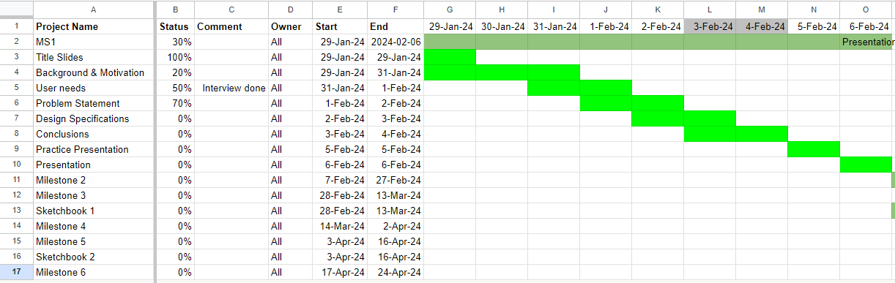

Figure 7. Gantt Chart for Milestone 1.

Lastly, our group utilizes a financial spreadsheet & establishes a budget. Our materials and purchase list (Fig. 8) is a way to keep track of all materials that we need or have already bought for our device. By keeping track of past and future purchases, as a group, we can divide costs that may be too great for one individual. It is also used to hold members accountable for the group's finances and to keep a constantly updated monetary record.

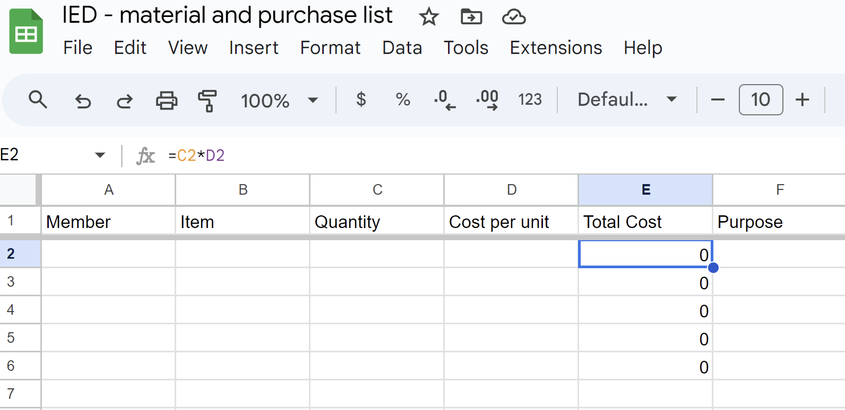

Figure 8. Financial Spreadsheet.

**Conclusion and Future Work**

In conclusion, our exploration into addressing the issue of limited access to stable energy in Nigeria has led us to propose a novel solution: the motor-free air compressor cleaner utilizing infrared radiation. This design endeavor stemmed from a recognition of the profound impact unreliable energy infrastructure has on daily life in Nigeria and the broader implications for economic growth and social well-being.

Throughout our analysis, we identified key user needs and design specifications, prioritizing affordability, energy consistency, safety, and durability. By benchmarking existing technologies and exploring design alternatives, we aimed to develop a solution that not only addresses these needs but also offers innovation and versatility.

Selecting our general problem included various conversations and considerations. As a team, we agreed that we wanted to create a solution to a problem that affects all parts of the world. With this common goal, we agreed on creating a product that would give households in Nigeria (and hopefully all countries) access to better-quality power.

Our design for the motor-free air compressor cleaner is underpinned by a set of critical specifications that directly address the identified user needs. Ensuring affordability is paramount, as we aim to provide a solution that is accessible to low and middle-income families in Nigeria. By highlighting cost-effectiveness through innovative design choices, such as the elimination of expensive components and the reduction of energy consumption, our cleaner offers a practical alternative for maintaining essential energy infrastructure. Moreover, our commitment to energy efficiency extends beyond mere functionality to encompass sustainability and environmental responsibility. Through the integration of infrared radiation technology, our cleaner not only ensures effective cleaning but also promotes energy conservation and long-term cost savings. Portability and versatility are also central to our design ethos, recognizing the diverse needs and contexts in which our solution will be deployed.

By prioritizing ease of transportation and adaptability to different surfaces and environments, our cleaner offers flexibility and utility to users across various settings. Safety and reliability are fundamental considerations, with robust safety features and durable construction integrated into the design to ensure user confidence and product longevity. Lastly, ease of maintenance is a key aspect of user experience, with intuitive design features and durable materials minimizing the need for frequent servicing and maximizing operational efficiency. In summary, these critical specifications not only reflect our commitment to addressing user needs but also underscore our vision of providing a transformative solution to the energy access challenges in Nigeria.

Our proposed motor-free air compressor cleaner stands out for its cost-effectiveness, portability, and versatility. By harnessing the power of infrared radiation, we eliminate the need for a motor, reducing energy consumption and maintenance costs. This lightweight and portable device can be easily transported and used in various locations, catering to the needs of low and middle-income families in Nigeria and potentially beyond.

Furthermore, our design prioritizes safety and durability, ensuring that users can rely on the product for long-term use without compromising their well-being. By leveraging advanced technology and thoughtful design considerations, we aim to contribute to a more sustainable and accessible energy infrastructure, not only in Nigeria but also in other regions facing similar challenges.

Our forthcoming actions will focus on several critical aspects of refining our motor-free air compressor cleaner design. Firstly, we will delve into devising suitable chambers for the air compressor, considering their optimal configuration and placement relative to a solar panel's surface. This entails meticulous assessment to ensure seamless integration and efficient operation.

Additionally, we'll explore the specific area of the compressor in relation to a solar panel, aiming to maximize coverage while minimizing spatial footprint. This entails a detailed examination of proportions and dimensions to strike an optimal balance between effectiveness and practicality.

Furthermore, we'll investigate the potential heat absorption capacity of the air compressor, strategizing ways to enhance its efficiency through innovative thermal management techniques. This will involve rigorous testing and analysis to ascertain the compressor's thermal performance under various conditions.

Moreover, we'll delve into implementing anti-reflective coatings and tapes to mitigate energy loss and enhance overall effectiveness. This will involve exploring advanced materials and application methods to optimize performance and durability.

Lastly, we'll dedicate attention to determining the optimal size and materials for constructing the compressors, considering factors such as weight, durability, and cost-effectiveness. This will entail a thorough evaluation and comparison of various options to identify the most suitable solution for our design.

By focusing on these next steps, we aim to further refine our motor-free air compressor cleaner design, advancing towards a sustainable and effective solution for addressing energy access challenges in Nigeria and beyond.

Considering that our product will be exposed to the hot sun for the majority of its operational time, we recognize the importance of ensuring user comfort and safety during handling. To address this concern, we plan to incorporate ergonomic handles or gloves equipped with cooling sheets or reflective materials. These additions will allow users to pick up and move the air compressor cleaner with ease, even in hot environments, without risking discomfort or burns from prolonged exposure to heat. By prioritizing user comfort and safety in the design, we aim to enhance the overall user experience and promote widespread adoption of our solution.

In essence, our journey through the MS3 Concept Solution Report has been one of exploration, innovation, and collaboration. By aligning our efforts with the needs of communities affected by energy poverty, we strive to make a meaningful difference in people's lives, empowering them with the resources they need to thrive in an increasingly interconnected world.

**Appendices**

**Appendix A - User Needs**

*Interview Questions and Answers*

Interviewee: Alyssa Okosun (Student at RPI)

Nationality: Nigerian & American

Major: CSE/CS

Have you had any experience with power outages in Nigeria? (Kismet) (Question #1)

Answer: Yes, I have. Power is very inconsistent in Nigeria. Right now, it is slightly improved.

How often do power outages occur? How long do they last? What about your life do the power outages regularly affect? (Kamsi) (Question #2)

Answer: - Occur pretty often, once a day. - six to eight hours long. - affects everyday life, watching TV, playing games, internet

What do you know about the causes of power outages? Are you aware of any proposed solutions? (Hayden) (Question #3)

Answer: - has to do with not utilizing hydroelectric power (Kainji Dam); the way the river runs across the country, some parts of Nigeria are further away; political corruption. - currently no, not right now.

Do people rely on other power sources during outages and if so what? Are there any problems or challenges that come with these alternate energy sources? (Jameson) (Question #4)

Answer: We do, a lot of people have big and small generators. The higher the class, the better the generator, some use solar-powered sources. - improving; petrol is too expensive, so they can’t top off the fuels; inverters need an external large power source to charge; expenses make it harder to charge, not everyone has access to solar-powered sources

What kind of appliances do you have in your home - what power needs do you have? (eg do you have AC? Need to charge your phone? How much of that power is inductive versus capacitive - ie dishwashers) (Question #5)

Answer: Appliances: TVs, fridges, ACs, charging electronics (phones, laptops, etc.), middle class = washer & dryer, lower class wash by hand; need hot water for showers - affected, some plumbing systems need water pumped into the home (gov’t is not best at providing homes with water, some have wells, some have water pumped from other sources; managed by estate/gov’t/private homes)

What changes or improvements would you like to see in the country's approach to solving the electricity problem? (Fanta) (Question #6)

Answer: Making the electricity separate from privatization (privatization = bad, not standardized), better sources of electricity other than coal, gas, petrol, hydro; better management of gov’t funds (it is getting better).

Table 5. Interpreted needs from interview

| **Question/Prompt** | **Customer Statement** | **Interpreted Need** |
| --- | --- | --- |
| Typical uses | 1. I have to run the generator every day and use a lot of fuel to power my house 2. I use an inverter once it’s charged to power the house | 1. The generator consumes a lot of fuel to run the house 2. An inverter is used as an alternative energy source to the generator when there is no power |
| Likes | 1. It powers the house 2. It helps me save fuel when I use the generator too much | 1. The generator is a nice, consistent alternative to regular fuel 2. A nice alternative to the generator |
| Dislikes | 1. It is loud and consumes too much expensive fuel 2. Needs to be charged regularly | 1. Needs to be quiet and cost-effective 2. It doesn’t need constant charging |
| Suggested improvements | 1. It is quiet and consumes less fuel 2. Charges regularly and easily | 1. Quiet and cost-effective 2. Can charge itself |

**Appendix B - Design Specifications**

Labeled sketches are shown below illustrating functional components of each design

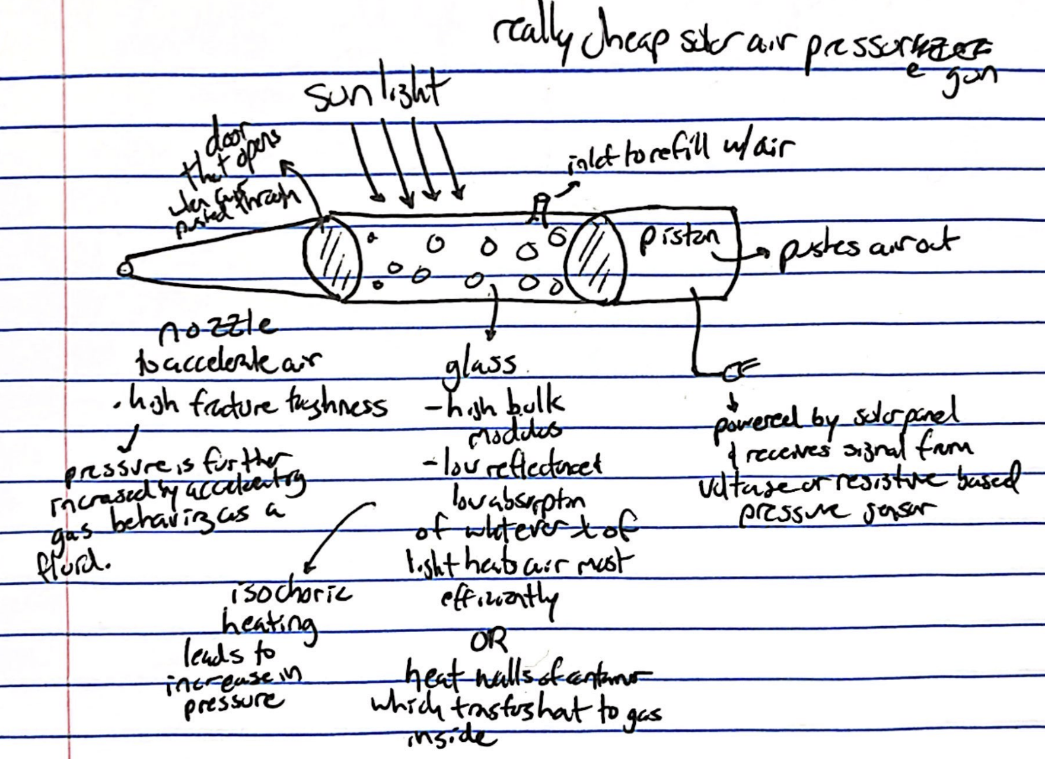

Figure B1 - Initial sketch for air compressor

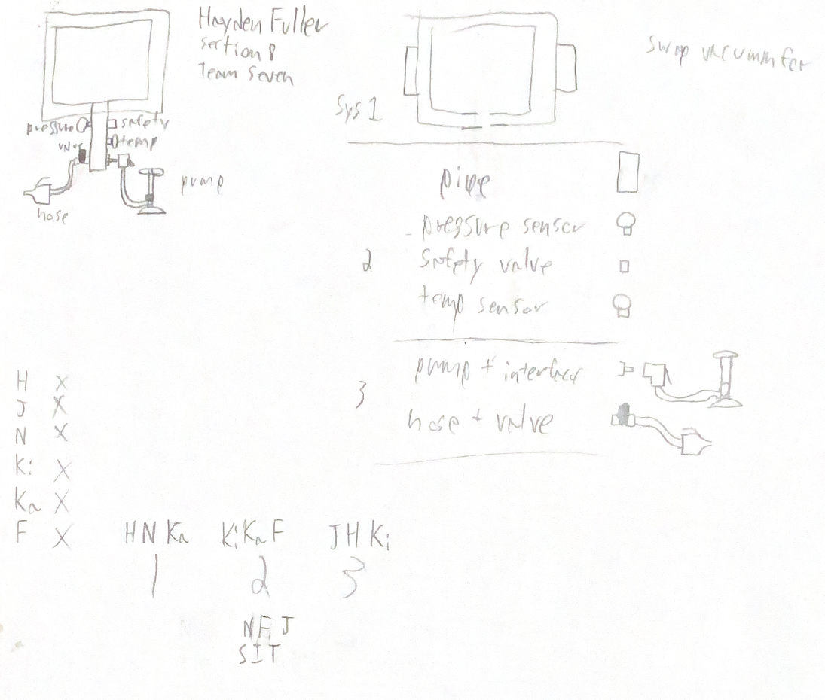

Figure B2 - High level diagram

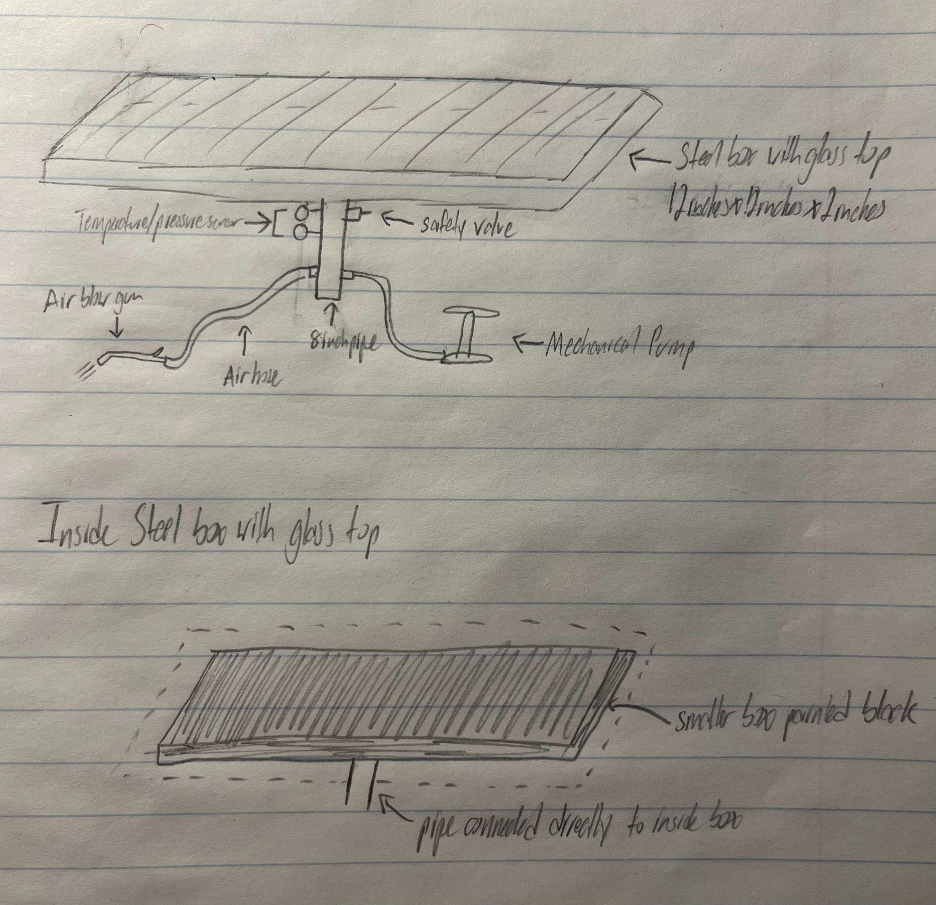

Figure B3 - Sketch of proposed concept solution

**Citations (IEEE)**

[1] “Nigeria to Improve Electricity Access and Services to Citizens” World Bank. Accessed January 31, 2024. [Online]. Available: <https://www.worldbank.org/en/news/press-release/2021/02/05/nigeria-to-improve-electricity-access-and-services-to-citizens#:~:text=85%20million%20Nigerians%20don't,access%20deficit%20in%20the%20world>

[2] “Solar panel cleaning: EGP innovative solution” Enel Green Power. [Online]. Accessed March 06, 2024. Available: <https://www.enelgreenpower.com/stories/articles/2018/10/solar-panel-cleaning-egp-innovative-solution>

[3] “Solutions” Clean Fizz. Accessed March 06, 2024. [Online]. Available: <https://www.cleanfizz.com/solutions-2/>

[4] “Industry innovation: solar panel cleaning robots - Professional Distributed PV Module Manufacturer”. Maysun Solar. Accessed March 06, 2024. [Online]. Available: <https://www.maysunsolar.com/blog-industry-innovation-solar-panel-cleaning-robots/>

[5]“Infrared heating,” Infrared Heating - an overview | ScienceDirect Topics, https://www.sciencedirect.com/topics/food-science/infrared-heating#:~:text=Unlike%20conventional%20heating%2C%20the%20energy,a%20quick%20and%20uniform%20heating. (accessed Mar. 17, 2024).

[6] V. Koester, “How does a thermos flask work?,” ChemistryViews, https://www.chemistryviews.org/how-does-a-thermos-flask-work/ (accessed Mar. 17, 2024).

[7] “The Online Materials Information Resource,” MatWeb, https://matweb.com/search/datasheet.aspx?MatGUID=5bb651ca58524e79a503011b2cd8083d&ckck=1 (accessed Mar. 17, 2024).

[8] “Product Pleco Solar” Blade Ranger. Accessed February 12, 2024. [Online]. Available: <https://bladeranger.com/pleco/>

[9] “Straight Sweep Windshield Wiper” Google Patents. Accessed February 12, 2024. [Online]. Available: <https://patents.google.com/patent/US4245369A/>

[10]“Debris Sensor for Cleaning Apparatus” Google Patents. Accessed February 12, 2024. [Online]. Available: <https://patents.google.com/patent/US20170202419A1/>

[11] “The 10 Best Air Compressors in 2024” Popular Mechanics. Accessed March 17, 2024. [Online]. Available: <https://www.popularmechanics.com/home/tools/a35323484/best-air-compressors/#product-9043c0f2-82f4-40d8-9d61-a6666ec03461>

[12] “Low Carbon Steel Sheets and Bars” McMaster-Carr. Accessed March 15, 2024. [Online]. Available: <https://www.mcmaster.com/products/steel/steel~/low-carbon-steel-sheets-and-bars/>

[13] “Borosilicate Glass Sheets” McMaster-Carr. Accessed March 15, 2024. [Online]. Available: <https://www.mcmaster.com/products/glass/glass~/borosilicate-glass-sheets/>

[14] “VIVOSUN Horticulture Highly Reflective Mylar” Amazon. Accessed March 15, 2024. [Online]. Available: <https://www.amazon.com/VIVOSUN-Horticulture-Highly-Reflective-Mylar/dp/B018VI75CS/ref=asc_df_B018VI75CS/?tag=hyprod-20&linkCode=df0&hvadid=198092200243&hvpos=&hvnetw=g&hvrand=9356489807573390058&hvpone=&hvptwo=&hvqmt=&hvdev=c&hvdvcmdl=&hvlocint=&hvlocphy=9005064&hvtargid=pla-348556453900&psc=1&mcid=766d0db7578f3fbba6f34dd33d6bf575&gclid=CjwKCAjw48-vBhBbEiwAzqrZVEfHj9WARoe8ThN9ksnLGKS5Ed20t297Q1cssw73CTWj8PjGiaK0khoCzWsQAvD_BwE>

[15] “Rust Oleum” Amazon. Accessed March 15, 2024. [Online]. Available: <https://www.amazon.com/Rust-Oleum-249061-Painters-Purpose-12-Ounce/dp/B002BWORSG/ref=sr_1_1?crid=3R69O869292G1&dib=eyJ2IjoiMSJ9.BTOKzE8qegbFda6djLPbRFwh2PVQkeRBCh7PwDtpWJTMC8-Yrle-0UkmF85-7zZwBxkU-2yb1eKakeypWIomk2KGOlxzCS6I34hcxu5s1mnykVGp9Y-gRU7uPEKens57f0qCH0-veG9snxOV0nT2LrqMW6aABZKWyQVXmQEs-Nz7FzV4C-ZfdaHLNDP8bSHH7s9D2BHTgDkqLUWKNTWLPYnDU0W0bcQ9STU9Hh1Nzlbvz7MDoIm_FLEROgXFRV2IuF7PGymK5fIGMqD8I659ar2zN8m-pfqWO3aTolYsFng.ugLMKPL_aCyStJAd4I8z2W_r63C4m8geMLvTV4LwBKk&dib_tag=se&keywords=black+spray+paint+for+metal&qid=1710701218&s=hi&sprefix=black+spray+%2Ctools%2C114&sr=1-1>

[16] “Frost King 16inx48in No Itch Utility Roll Insulation” Home Depot. Accessed March 15, 2024. [Online]. Available: <https://www.homedepot.com/p/Frost-King-16-in-x-48-in-No-Itch-Utility-Roll-Insulation-R-4-CF1/203486076?g_store=&source=shoppingads&locale=en-US&pla&mtc=SHOPPING-BF-CDP-GGL-D26P-026_001_PIPE_FITTING-NA-NA-NA-PMAX-NA-NA-NA-NA-NBR-NA-NA-NEW-PMax&cm_mmc=SHOPPING-BF-CDP-GGL-D26P-026_001_PIPE_FITTING-NA-NA-NA-PMAX-NA-NA-NA-NA-NBR-NA-NA-NEW-PMax-71700000097492030--&gad_source=1&gclid=CjwKCAjw48-vBhBbEiwAzqrZVFAIHeHZkOeVbFfNkOTXN3DrMndjPJeBYlhGfbaZJI9q_jfegLNqFxoCHcsQAvD_BwE&gclsrc=aw.ds>

[17]“Low-Carbon Steel Round Tubes” McMaster-Carr Accessed March 15, 2024. [Online]. Available: <https://www.mcmaster.com/products/tubing/low-carbon-steel-round-tubes/?s=low-carbon+steel+tubing>

[18] “Air Tank Gauge” Amazon. Accessed March 15, 2024. [Online]. Available: <https://www.amazon.com/Performance-Tool-0-200-Accessory-W10055/dp/B000N349HO/ref=pd_bxgy_d_sccl_1/138-0024991-7942627?pd_rd_w=1ermh&content-id=amzn1.sym.2b132e63-5dcd-4ba1-be9f-9e044543d59f&pf_rd_p=2b132e63-5dcd-4ba1-be9f-9e044543d59f&pf_rd_r=GH4YDT7ST9XZ8SYBHM6Y&pd_rd_wg=R3da5&pd_rd_r=bea2bf03-ff0c-45fc-ba7e-901695172057&pd_rd_i=B000N349HO&psc=1>

[19] “Bimetal Dial Thermometer” Amazon. Accessed March 15, 2024. [Online]. Available: <https://www.amazon.com/Solimeta-Thermometer-Lead-Free-Accuracy-Adjustable/dp/B08F3FB2GG/ref=asc_df_B08F3FB2GG/?tag=hyprod-20&linkCode=df0&hvadid=491816127744&hvpos=&hvnetw=g&hvrand=4479897445514571811&hvpone=&hvptwo=&hvqmt=&hvdev=c&hvdvcmdl=&hvlocint=&hvlocphy=9005064&hvtargid=pla-1183874874193&mcid=505afd0707263097918f8d2ca43e329a&gclid=CjwKCAjw48-vBhBbEiwAzqrZVDB_Gcat1-etz2OtFiy6pI0fShQQzLUTcNC2TDu3_EiYj-HX2EfMuBoCmR8QAvD_BwE&th=1>

[20] “Air Tank Valve (1/8‘‘ NPT)” Amazon. Accessed March 15, 2024. [Online]. Available:<https://www.amazon.com/Performance-Tool-0-200-Accessory-W10055/dp/B006G4HSTU/ref=pd_bxgy_d_sccl_1/138-0024991-7942627?pd_rd_w=1ermh&content-id=amzn1.sym.2b132e63-5dcd-4ba1-be9f-9e044543d59f&pf_rd_p=2b132e63-5dcd-4ba1-be9f-9e044543d59f&pf_rd_r=GH4YDT7ST9XZ8SYBHM6Y&pd_rd_wg=R3da5&pd_rd_r=bea2bf03-ff0c-45fc-ba7e-901695172057&pd_rd_i=B000N349HO&th=1>

[21] “Milton MNPT ASME Saftey Valve'' Amazon. Accessed March 15, 2024. [Online]. Available: <https://www.amazon.com/Milton-S-1090-200-MNPT-Safety-Valve/dp/B005IUKMQ4?source=ps-sl-shoppingads-lpcontext&ref_=fplfs&psc=1&smid=ATVPDKIKX0DER>

[22] “Bike Floor Pump” Amazon. Accessed March 15, 2024. [Online]. Available: <https://www.amazon.com/CLOLOP-Portable-Schrader-Balloons-Swimming/dp/B0BCVM65XP/ref=asc_df_B0BCVM65XP/?tag=hyprod-20&linkCode=df0&hvadid=632276210150&hvpos=&hvnetw=g&hvrand=9155168970532156605&hvpone=&hvptwo=&hvqmt=&hvdev=c&hvdvcmdl=&hvlocint=&hvlocphy=9005064&hvtargid=pla-1946217273117&mcid=78079fa6203e34c39adf7c7d55b66a84&gclid=CjwKCAjw48-vBhBbEiwAzqrZVH5FfaZOdfWJAktlbjKtZERgLBoXQpUHJOsJQ3xC-P1Jqc1HBhJiIRoCSQUQAvD_BwE&th=1>

[23] “Schrader Valve Standard Valve Core” Amazon. Accessed March 15, 2024. [Online]. Available: <https://www.amazon.com/Valve-Schrader-Standard-Threads-Compressor/dp/B0CNLC38V1/ref=asc_df_B0CNLC38V1/?tag=hyprod-20&linkCode=df0&hvadid=680438805583&hvpos=&hvnetw=g&hvrand=2615287045694356862&hvpone=&hvptwo=&hvqmt=&hvdev=c&hvdvcmdl=&hvlocint=&hvlocphy=9005064&hvtargid=pla-2331247249437&mcid=ae5b368df37b3f62bad598076345f4bd&gad_source=4&th=1>

[24] “High Volume Powerful Industrial Air Blow Gun” Amazon. Accessed March 15, 2024. [Online]. Available: <https://www.amazon.com/Industrial-Extensible-Compressor-Accessories-Gun-Extended/dp/B07DQJDZNR>

[25] “YOTOO Hybrid Air Hose” Amazon. Accessed March 15, 2024. [Online]. Available: <https://www.amazon.com/YOTOO-Lightweight-All-Weather-Flexibility-Restrictors/dp/B07Y816P9T/ref=sr_1_1_sspa?crid=N8EXQ4QRS8JK&dib=eyJ2IjoiMSJ9.qrcRVFCDITUriN_EnJ5Hgvep1ilqeQ-FAoAhs-aL9VtmEL_Aho2Qt1dixvNQnLCYx16Vfpk04SshOWj7c-qzVYSsVD8_3dx9OkAw7jIZ_me9rTuNB_X4eZ98ZMF4z6RUXr2cZItOastnSoMxH3xt5wwlQoRRbiUCG78Aj9ZMp74eZ3oWXCgEkQSY3yoLgzv4Tsi4peKLh6XBR7Be253kowMkPeyVRKj9gHQRlqGCLaJ5ZfGLn3lRbN3iQRXj_1Dpja_ClzEnOHzmhp6RYMZwEAT8ZCsHskjlo4XHxSxXD04.MnvtvZ2-KYGsVEoTq4dFKp_FCFllW868yfu1f6vYtCY&dib_tag=se&keywords=185+psi+air+hose&qid=1710649920&s=hi&sprefix=185+psi+air+hose%2Ctools%2C104&sr=1-1-spons&sp_csd=d2lkZ2V0TmFtZT1zcF9hdGY&psc=1>

[26] “Steel Industrial Quick Coupler Set” Harbor Freight. Accessed March 15, 2024. [Online]. Available: <https://www.harborfreight.com/steel-industrial-quick-coupler-set-5-piece-63566.html>